Mission of the Electrical Engineering Technology Department.
“To excel as a center of knowledge through applied research and innovation in the field of electrical Engineering technology. The department is committed to providing quality education in the fundamentals and applications of electrical technology, along with hands-on skills, to produce competent technologists prepared for successful professional careers. The department aims to equip students to contribute effectively to scientific, economic, and social development.”

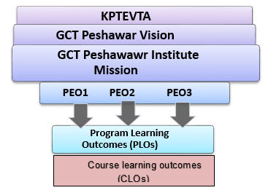

Bachelor of Electrical Engineering Technology Department
Program Educational Objectives (PEOs),
The fundamental objectives of the program are focused on producing electrical engineering technologists who:
- “are competent and employable, able to demonstrate sound knowledge and hands-on skills to meet the needs of the modern industry.”

- “apply knowledge and skills to creatively analyze, implement and troubleshoot electrical and electronic systems in diverse technical environments.”

- “Exhibit effective communication, team work and interpersonal skills while adhering to high standards of professional ethics and lifelong learning in their careers.”

Mapping of PEOs to Mission & Vision
PEOs |  |  | Electrical Engineering Technology Department
PEOs | Vision | Mission | Mission
PEO-01
PEO-02
PEO-03

PEOs mapping to Department Mission
PEOs | Department mission
- “are competent and employable, able to demonstrate sound knowledge and hands-on skills to meet the needs of the modern industry.” | To provide students with high quality engineering Technology knowledge at undergraduate.
- “apply knowledge and skills to creatively analyze, implement and troubleshoot electrical and electronic systems in diverse technical environments.” | To prepare technologists for innovative solutions with focus on design and research.
- “Exhibit effective communication, team work and interpersonal skills while adhering to high standards of professional ethics and lifelong learning in their careers.” | Equipping students in scientific, economic and social development to serve the society.

PEO-PLO Mapping (Aligned with Revised PEOs)

PEOs →  PLOs  ↓ | PEO 1  (Knowledge, skills, employability | PEO 2  (Problem-solving, analysis, implementation) | PEO 3 (Communication, ethics, professionalism)
PLO-1  Engineering Technology Knowledge | ✓ | ✓
PLO-2  Problem Analysis | ✓ | ✓
PLO-3  Design/Development of Solutions | ✓ | ✓
PLO-4  Investigation |  | ✓
PLO-5  Modern Tool Usage | ✓ | ✓
PLO-6  The Engineer and Society | ✓
PLO-7  Environment and Sustainability | ✓
PLO-8  Ethics |  |  | ✓
PLO-9  Individual and Team Work | ✓ | ✓ | ✓
PLO-10  Communication |  |  | ✓
PLO-11  Project Management | ✓ | ✓
PLO-12  Lifelong Learning | ✓ | ✓

Scheme of Study
 | SEMESTER-I
Suggested Course Codes | Course Title | Knowledge Area/Domain | Credit Hrs.  (Th+Lab) | Contact Hrs.  (Th+Lab)
ELH-111/  ELH-112 | Islamic Studies /  Social Ethics | Art & Humanities-I | 3+0 | 3+0
ELE-111 | Communication Skills | Expository Writing-I | 3+0 | 3+0
ELQ-111 | Calculus & Analytical Geometry | Quantitative Reasoning-I | 2+0 | 2+0
ELN-112 | Applied Physics | Natural Sciences-I | 2+1 | 2+3
ELC-111 | Information and Communication  Technology | Computing-I | 1+1 | 1+3
ELT-111 | Electrical Workshop | Electrical Engineering Technology  Foundation-I | 0+2 | 0+6
 | Subtotal |  | 11+4 =15 | 11+12 =23
 | SEMESTER-II
ELH-121 | Pakistan Studies | Art & Humanities -II | 3+0 | 3+0
ELQ-121 | Differential Equations | Quantitative Reasoning-II | 2+0 | 2+0
ELN-122 | Natural Science Elective-I | Natural Sciences-II | 2+1 | 2+3
ELM-121 | Management Science Elective-I | Management Sciences-I | 3+0 | 3+0
ELC-121 | Computer Programming | Computing-II | 1+1 | 1+3
ELT-121 | Linear Circuit Analysis | Electrical Engineering Technology  Foundation-II | 1+1 | 1+3

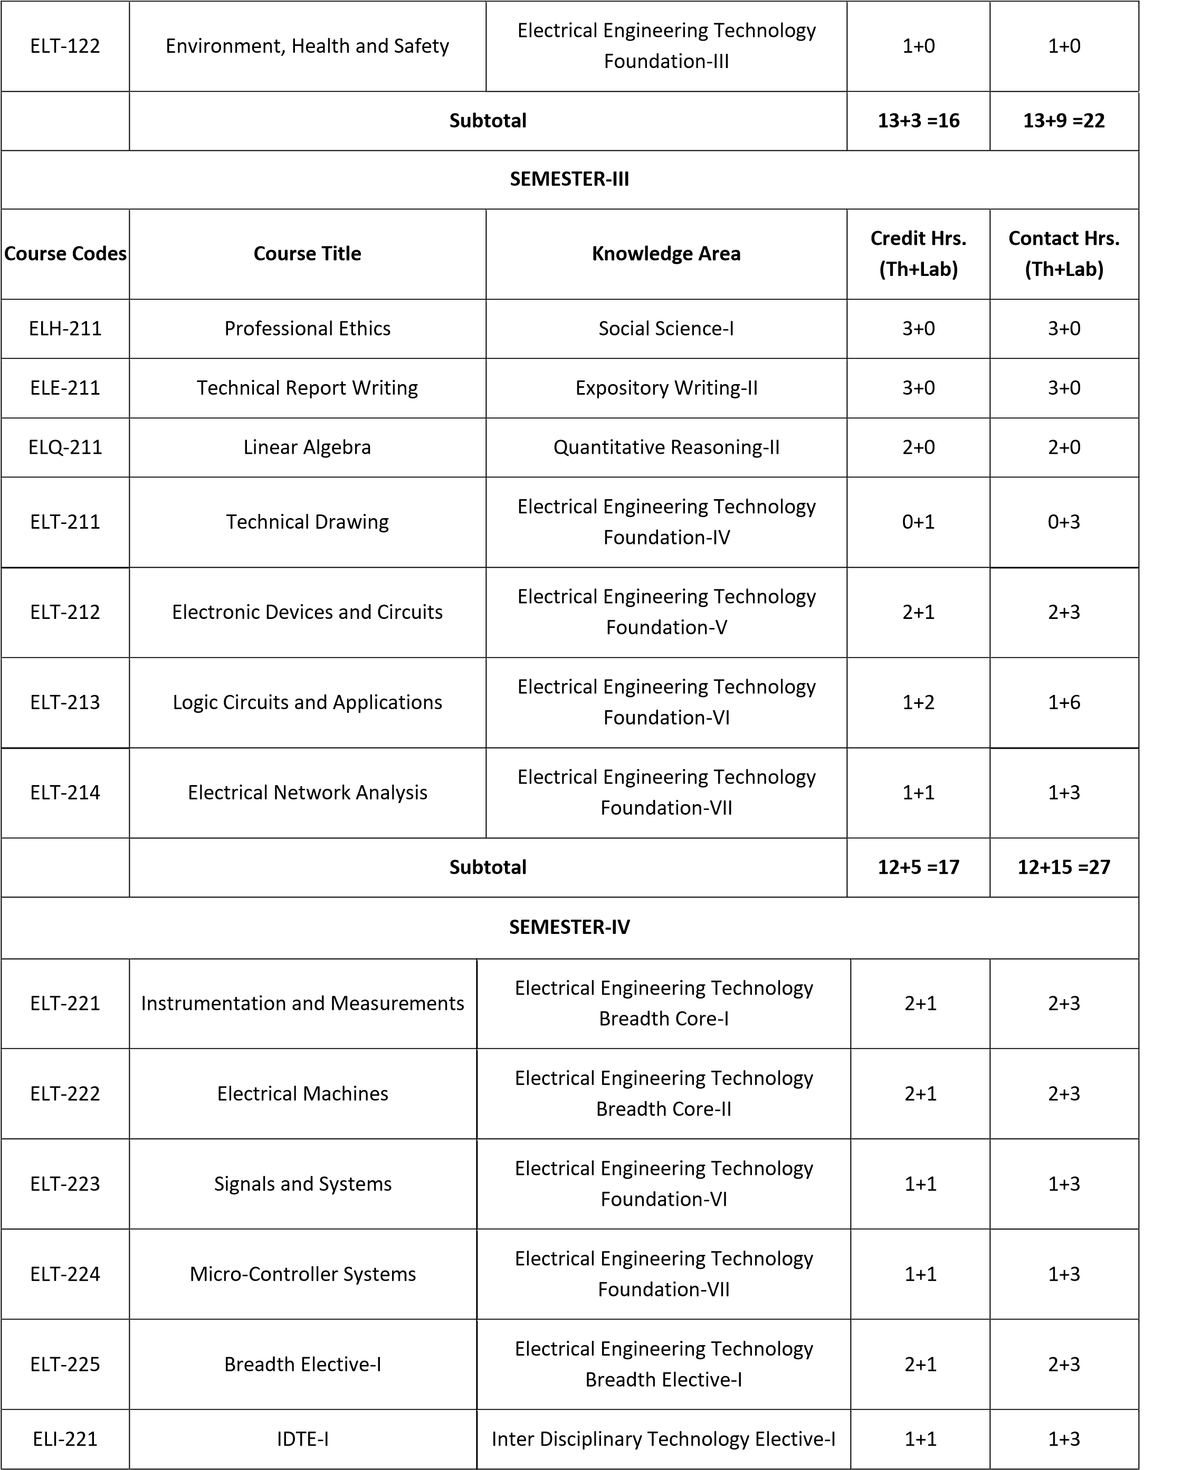
 |  | Subtotal |  | 9+6 =15 | 9+18 =27
SEMESTER-V
Course Codes | Course Title |  | Knowledge Area | Credit Hrs.  (Th+Lab) | Contact Hrs.  (Th+Lab)
ELT-311 | Control Technology |  | Electrical Engineering Technology  Depth Core-I | 2+1 | 2+3
ELT-312 | Communication Systems |  | Electrical Engineering Technology  Depth Core-II | 2+1 | 2+3
ELT-313 | Breadth Elective-II |  | Electrical Engineering Technology  Breadth Elective-II | 1+1 | 1+3
ELT-314 | Depth Elective-I |  | Electrical Engineering Technology  Depth Elective-I | 2+1 | 2+3
ELT-315 | Depth Elective-II |  | Electrical Engineering Technology  Depth Elective-II | 2+1 | 2+3
ELT-316 | Project Part-I |  | Electrical Engineering Technology  Domain Project | 0+3 | 0+9
 |  | Subtotal |  | 9+8 =17 | 9+24 =33
SEMESTER-VI
ELM-321 | Management Elective-II |  | Management Sciences-II | 3+0 | 3+0
ELT-321 | Depth Elective-III |  | Electrical Engineering Technology  Depth Elective-III | 2+1 | 2+3
ELT-322 | Depth Elective-IV |  | Electrical Engineering Technology  Depth Elective-IV | 2+1 | 2+3
ELT-323 | Depth Elective-V |  | Electrical Engineering Technology  Depth Elective-V | 2+1 | 2+3
ELI-321 | IDTE-II |  | Inter Disciplinary Technology Elective-  II | 1+1 | 1+3
ELT-324 | Project Part-II |  | Electrical Engineering Technology  Domain Project | 0+3 | 0+9
 |  | Subtotal |  | 10+7 =17 | 10+21 =31

SEMESTER-VII
Course Codes | Course Title | Knowledge Area |  | Credit Hrs.  (Th+Lab) |  | Contact Hrs.  (Th+Lab)
ELT-411 | Supervised Industrial Training (Optional) | Electrical Engineering Technology  Domain Industrial Training |  | 16 |  | 40 (per Week)
ELH-411 ELM-411 | Social Sciences / Management Sciences  Elective | Social Science-II /  Management Sciences-III |  | 2+0 |  | 2+0
ELT-412 | Depth Elective-VI | Electrical Engineering Technology  Depth Elective-VI |  | 2+1 |  | 2+3
ELT-413 | Depth Elective-VII | Electrical Engineering Technology  Depth Elective-VII |  | 2+1 |  | 2+3
ELT-414 | Depth Elective-VIII | Electrical Engineering Technology  Depth Elective-VIII |  | 2+1 |  | 2+3
ELT-415 | Depth Elective-IX | Electrical Engineering Technology  Depth Elective-IX |  | 2+1 |  | 2+3
ELC-411 | Computing Elective-I | Computing-III |  | 1+1 |  | 1+3
 | Subtotal |  |  | 11+5=16 |  | 11+15 =26
SEMESTER-VIII
ELT-421 | Supervised Industrial Training  (Compulsory) | Electrical Engineering Technology  Domain Industrial Training |  | 16 |  | 40 (per Week)
 | Subtotal |  |  | 0+16= 16 |  | 0+40= 40
Total Credit Hours & Contact Hours in Four Years  (When SIT conducted in both 7th and 8th Semester) |  |  | 64+65 = 129 |  | 64+195=259
Theory vs Practical with respect to Contact Hours |  |  | Theory  Practical |  | 64 (24.71%)  195 (75.29%)
Total Credit Hours & Contact Hours in Four Years  (When optional courses conducted instead of SIT in 7th semester) |  |  | 75+54 = 129 |  | 75+162 =237
Theory vs Practical with respect to Contact Hours |  |  | Theory  Practical |  | 75 (31.65%)  162 (68.35%)

Table of elective courses – grouped across depth and breadth categories – Table 3.3.
Elective Breadth Courses
Course Code | Title | Knowledge Area | Credit Hrs. | Contact Hrs.
ELT-225 | Electrical Power Transmission | Electrical Engineering Technology Breadth Elective-I | 2+1 | 2+3
ELT-313 | Electrical Power Distribution and  Utilization | Electrical Engineering Technology Breadth Elective-II | 1+1 | 1+3

Elective Depth Courses
Course Code | Title |  | Knowledge Area | Credit Hrs. | Contact Hrs.
ELT-314 | ▪  ▪  ▪  ▪  ▪  ▪  ▪  ▪  ▪  ▪  ▪  ▪  ▪  ▪  ▪  ▪  ▪  ▪  ▪  ▪ | Switchgear and Protective Devices Technology  Power Electronics  Energy Conservation and Auditing  Industrial Drives and PLC  Power Generation Technology  High Voltage Technology  Renewable Energy Technologies  Machine Repair and Maintenance  Electrification Technology  Electrical Appliances Repair  Smart Grid Technology  Electrical Safety  Automobile and Electric Vehicle Technologies  Fiber Optics Technology  Sensor Networks  Embedded Systems  Integrated Circuits Technology  Mobile Phone Assembly and Repair  Telecommunication Systems Technology  Wireless Technology | Depth Elective-I | 2+1 | 2+3
ELT-315 | ▪  ▪  ▪  ▪  ▪  ▪  ▪  ▪  ▪  ▪  ▪  ▪  ▪  ▪  ▪  ▪  ▪  ▪  ▪  ▪ |  | Depth Elective-II | 2+1 | 2+3
ELT-321 | ▪  ▪  ▪  ▪  ▪  ▪  ▪  ▪  ▪  ▪  ▪  ▪  ▪  ▪  ▪  ▪  ▪  ▪  ▪  ▪ |  | Depth Elective-III | 2+1 | 2+3
ELT-322 | ▪  ▪  ▪  ▪  ▪  ▪  ▪  ▪  ▪  ▪  ▪  ▪  ▪  ▪  ▪  ▪  ▪  ▪  ▪  ▪ |  | Depth Elective-IV | 2+1 | 2+3
ELT-323 | ▪  ▪  ▪  ▪  ▪  ▪  ▪  ▪  ▪  ▪  ▪  ▪  ▪  ▪  ▪  ▪  ▪  ▪  ▪  ▪ |  | Depth Elective-V | 2+1 | 2+3
ELT-412 | ▪  ▪  ▪  ▪  ▪  ▪  ▪  ▪  ▪  ▪  ▪  ▪  ▪  ▪  ▪  ▪  ▪  ▪  ▪  ▪ |  | Depth Elective-VI | 2+1 | 2+3
ELT-413 | ▪  ▪  ▪  ▪  ▪  ▪  ▪  ▪  ▪  ▪  ▪  ▪  ▪  ▪  ▪  ▪  ▪  ▪  ▪  ▪ |  | Depth Elective-VII | 2+1 | 2+3
ELT-414 | ▪  ▪  ▪  ▪  ▪  ▪  ▪  ▪  ▪  ▪  ▪  ▪  ▪  ▪  ▪  ▪  ▪  ▪  ▪  ▪ |  | Depth Elective-  VIII | 2+1 | 2+3
ELT-415 | ▪  ▪  ▪  ▪  ▪  ▪  ▪  ▪  ▪  ▪  ▪  ▪  ▪  ▪  ▪  ▪  ▪  ▪  ▪  ▪ |  | Depth Elective-IX | 2+1 | 2+3

